**Motion Detection using PIR Sensor**

**Introduction**

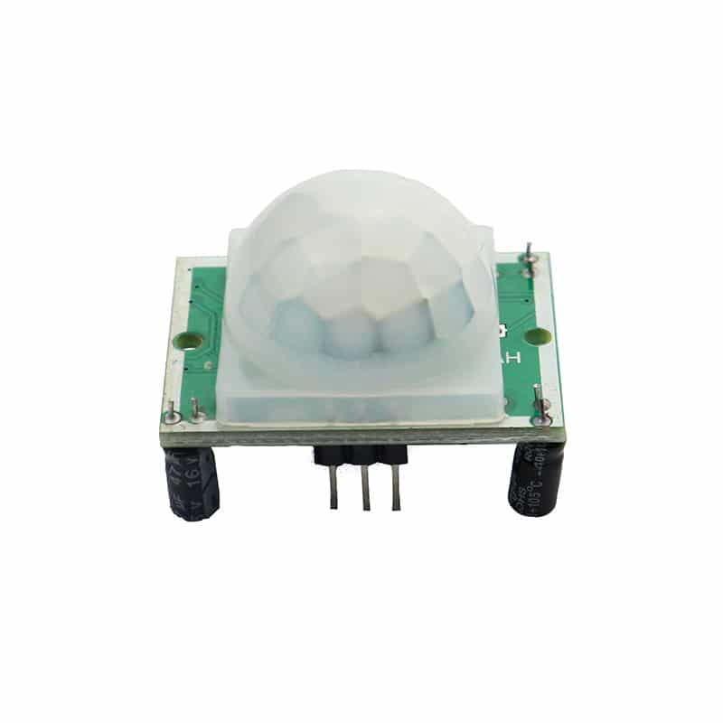PIR sensor based security system is a wireless security system in which pyro electric infrared motion sensors are placed in four sides I. E front, back, left and right of the area to be covered. By this it can detect motion from any side and turns on the audio visual alarm. It also displays the side where the motion (intruder) is detected. The PIR sensor detects the IR radiation which is emitted from the humans and then it produces a digital output.

PIR sensor detects a human being moving around within **approximately 10m** from the sensor. This is an average value, as the actual detection range is between 5m and 12m. PIR are fundamentally made of a pyro electric sensor, which can detect levels of infrared radiation.

**COMPONENTS**

1. Arduino Uno
2. Breadboard
3. PIR Sensor
4. Buzzer
5. Led
6. Resistor

**Application**

 This system can be used in museums to protect the valuable things.

• Used in automatic door bell system to ring the bell when a human is detected.

• Helpful in defence system to detect the humans in warfield.

• Also used in toys that automatically produce sound.

• To protect the lockers in banks from robbery.

**Objective**

During this activity ,you will help students to achieve following objectives

1. Understanding the principle and operation of PIR sensor to detect motion

2. Design algorithm and flowchart to detect motion and get alerted

3. Programming PIR sensor using Arduino uno

4. Interfacing PIR sensor withArduino uno

**Programming steps**

1. Initialise PIR sensor as input pin and pin sensor to read values

2. initialise LED as output pin

3. Initialise buzzer as output pin

4.define ports for sensor input ,led output and buzzer output

5.check output of motion sensor

6.read output value of motion sensor

7.if motion is detected ,PIR sensor output gets HIGH these will get alert to buzzer and LED blink.

8. if motion is not detected ,PIR sensor output remains LOW

**PROGRAM**

int pinSensor =2;

int pinLed =12;

int pinBuzzer =13;

int pirSensor =0;

void setup()

{

  pinMode(pinSensor, INPUT);

  pinMode(pinLed, OUTPUT);

  pinMode(pinBuzzer, OUTPUT);

}

void loop()

{

  pirSensor = digitalRead(pinSensor);

  if (pirSensor == HIGH)

  {

    digitalWrite(pinLed, HIGH);

    tone(pinBuzzer, 1000, 500);

  }

  else {

    digitalWrite(pinLed, LOW);

  }

  delay(10);

}

**Hardware**

**Instructions**

1.connect VCC and GND pin of PIR sensor to the 5v supply and GND pin arduino

2.connect signal out pin sensor to the digital data input (D2)

3.connect positive polarity of buzzer to digital input pin13

4. connect digital input pin 12 to cathode of LED

5. upload an arduino code

